**7-3 Project Two**

**Daryl Murtha**  
**Department of Computer Science, Southern New Hampshire University**  
**CS 255: System Analysis and Design**  
**Kim-Marie Foss**  
**June 19, 2025**

**Introduction**

The DriverPass System is designed to streamline driving lesson scheduling, payment processing and user management. This document provides a detailed system design incorporating object and process modeling to ensure efficiency, scalability, and ease of use. The system will be implemented with UML diagrams, defining key interactions and processes, as well as a technical specification outlining software, hardware, security, and network infrastructure requirements.

.

## UML Diagrams

### UML Use Case Diagram

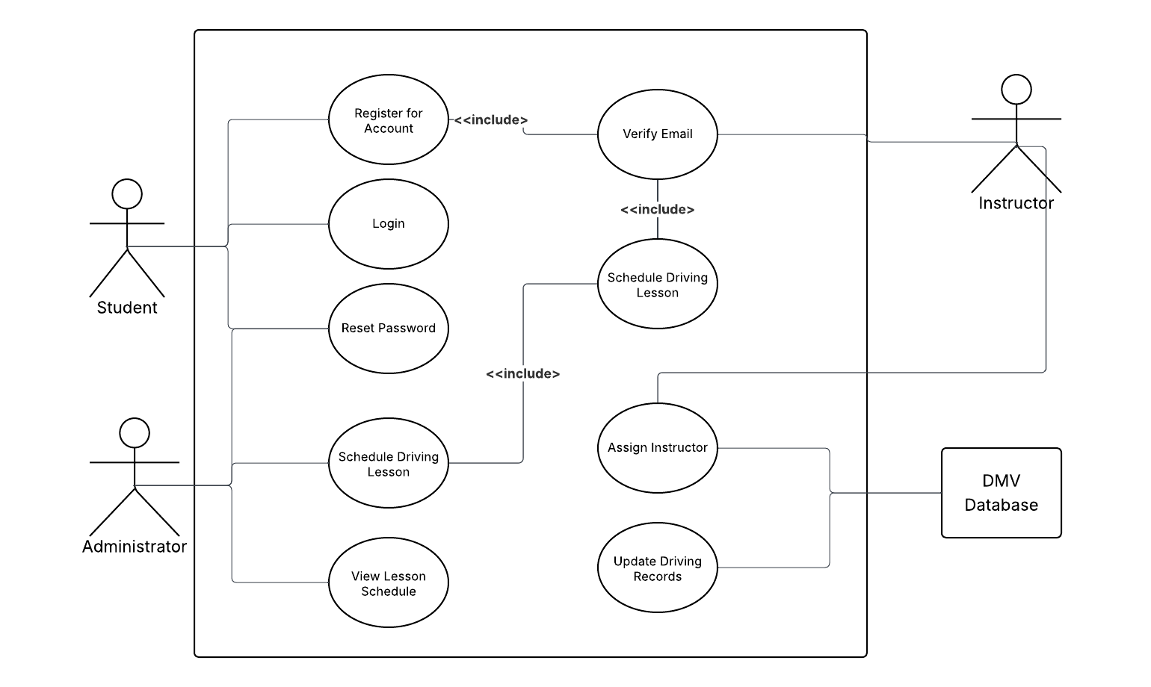

### UML Activity Diagrams

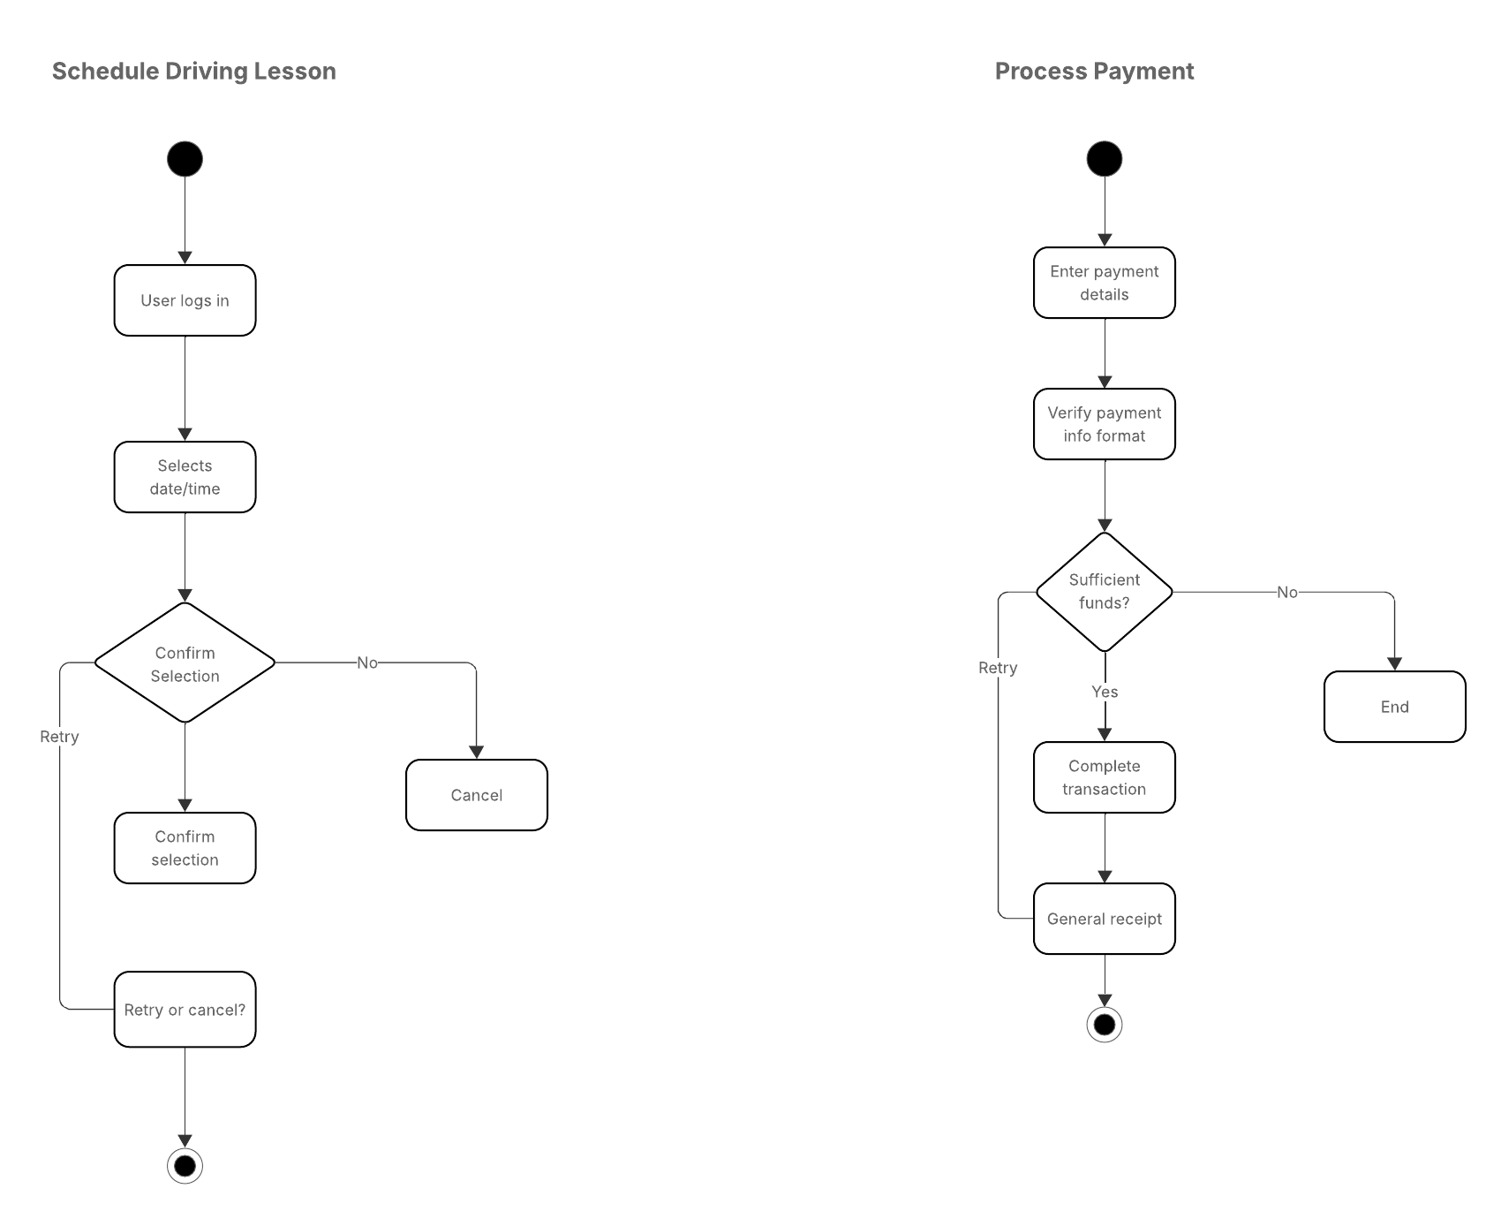

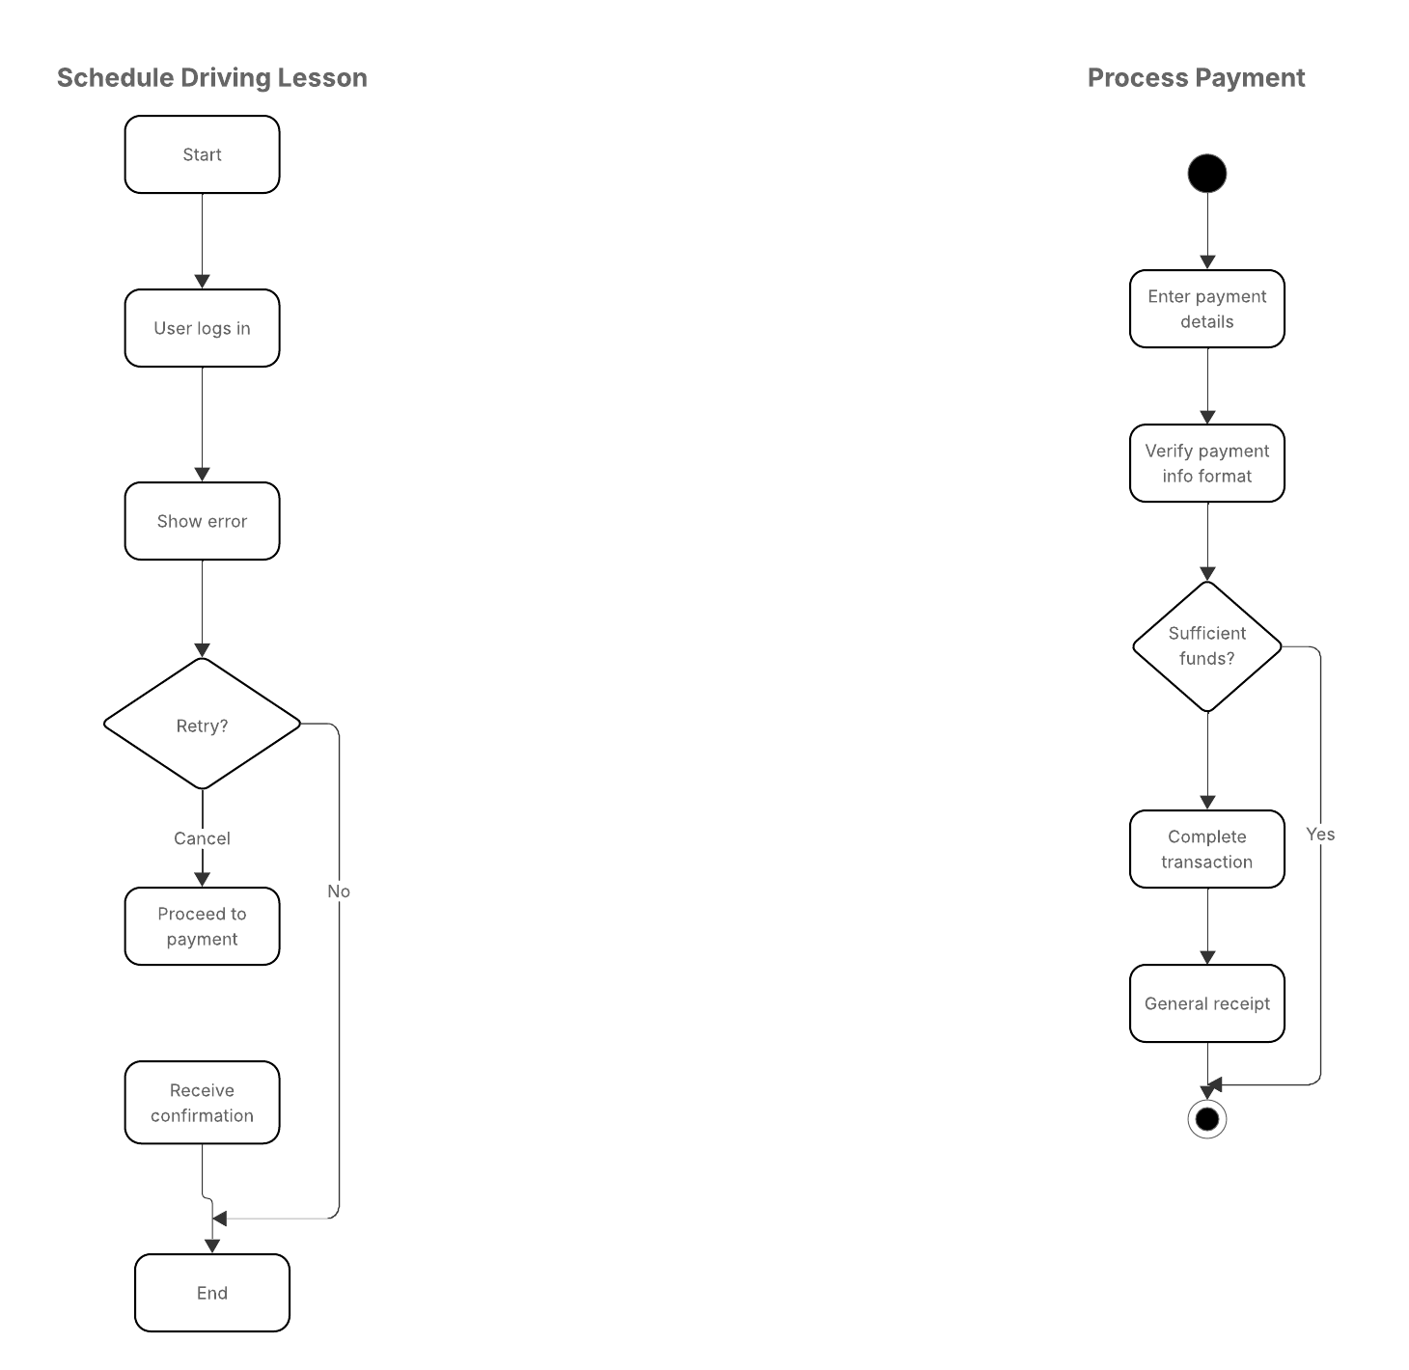

### UML Sequence Diagram

### UML Class Diagram

## Technical Requirements

**Software Requirements**

* Lucidchart (For UML modeling)
* Database System (Cloud-hosted SQL)
* Frontend Framework (React or Angular)
* Backend System (Node.js with Express API)

**Hardware Requirements**

* Servers: Cloud-based with load balancing
* Client Devices: Desktop & Mobile compatibility

**Security Considerations**

* Authentication: Role-based access control
* Encryption: Secure payment processing with AES-256 encryption
* Data Storage: Cloud backup with automated recovery

**Network & Integration Requirements**

* DMV API Integration for license verification
* Payment Gateway Integration (Stripe, PayPal)

**Conclusion**

The DriverPass System is designed to ensure seamless scheduling, secure transactions, and ease of use for both customers and instructors. By incorporating object and process modeling, the system will be efficient, scalable, and secure, meeting all business requirements effectively.